Truckcom User Guide

The following is a short guide to the uses of Truckcom Vendor Interface. It shall cover several of the main areas used in day to day operations and highlight areas to help improve communication between haulier, operator and customer.

Accessing the Truckcom Website

To access the Truckcom website firstly go to:

http://www1.truckcom.net/ctmLogon.aspx?Company=OOCL&Mode=Subcontractor

Once you are at the home page you can enter your Username and Password, which was sent to you in your Truckcom activation email, in to the boxes provided and click Logon to be taken to the Job Screen.

Invoicing.

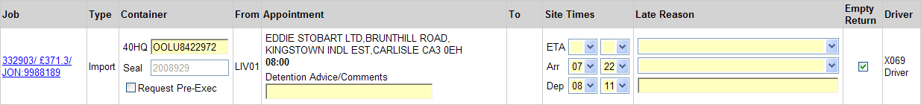

Firstly check the job order amount is correct, if not you must raise this with OOCL, and await amendment if required. Then when invoicing you must quote JON:9988189, Job Amount £371.30 (example in above case) and container number, otherwise your invoice will be rejected. All invoices must be sent to JINVLEV@oocl.com.

Pre Exec (Empty and Laden).

Container No | Pre Exec Button | Seal Number | Arr Time | Dep Time | Re use Container

In above screen shot you will see, in column 3, a space for the container number and the seal number, for imports this will already be completed, for exports these will be blank and must be filled in for execing purposes. Seal number must be completed in full, complete number and all alpha pre fix. If the import is not being empty returned but reused for an export then the empty return button must be unchecked.

Save
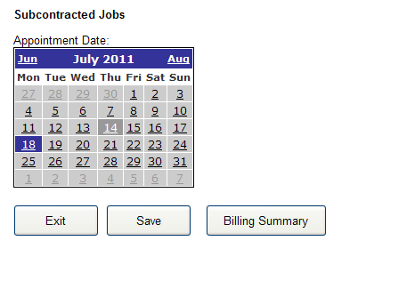
Laden Export Container Exec.

The following needs to be entered into Truckcom BEFORE request pre-exec.

- Container number (as above).
- Seal number (as above).
- Arr Times (as above).
- Dep Times (as above).
- Check pre exec request (as above).
- Click Save (as above).

Empty Container Exec.

The following needs to be entered into Truckcom BEFORE request pre-exec.

- Arr Times (as above).
- Dep Times (as above).
- Check pre exec request (as above).
- Click Save (as above).

If the above has been followed but the container is still not exec’d then please email SHAOUKEX@oocl.com with the details.

Late Advice.

Any lates can also be advised through Truckcom by filling the drop down menus in the 7th and 8th columns. The following 3 drop down menus MUST be filled or the advice will not be sent through to OOCL and the customer.

3 drop down menus MUST be completed for the late advice to be sent

- The ETA drop down menu must be filled in with the most accurate ETA that can be given and must be updated if any change to the ETA occurs.
- The top drop down menu must be filled with the reason why the vehicle is running late.
- The middle drop down menu must be filled in with what the vehicle is currently doing.
- The bottom section is for any additional information you may wish to give, i.e. road names or junction numbers

NOTE: If a driver has a PDA he MUST use it to advise all lates and ETA’s, this must not be over typed or amended using the website.

Advising Detention and uploading PODs.

- All detention must be advised, via "detention advice/comments" in truckcom and at least 30 mins before detention is due to be incurred. Once entered click save.

Arrival and Departure times can be inputted here

- Update "detention advice/comments" advising when the driver is departing.
- Arrival and departure times MUST be entered into truckcom before the detention is checked on Monday, no exceptions.
- Finally, Please ensure the POD is uploaded by the following Monday AM (detention is check on Monday for the previous week).
- Detention is checked and paid the following week.
- If you are still waiting for detention payment, uploaded a POD after Monday or wish the j/o to be updated asap then please email UKTRNSPT@oocl.com.

Detention is only payable when (a) 3hrs has elapsed from the booking time (b) the driver arrived on time (c) If arrival & departure times are present and correct when detention is checked on Monday and (d) the above process has been followed.

If detention has occurred on a job then a POD can be uploaded on to the website so that any detention will be paid. This can be done by firstly clicking on to the job order number in the 1st column on the left hand side of the screen; this will take you to the following screen.
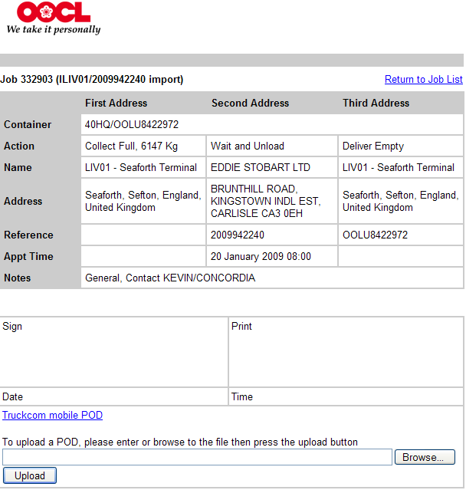

Once in this screen, click the Browse Button on the bottom right and select the POD that matches the job. The POD MUST have the arrival and departure times, along with the customer signature. Once the correct POD has been selected, click the upload button on the bottom left of the screen.

NOTE: If a driver has a PDA then he MUST get the customer site to sign his PDA confirming his arrival and departure times and any demurrage incurred. This will automatically upload a POD for that job.

Updating Vehicle Availability.

Hauliers can advise and update their availability throughout the day.

- Click the change button.

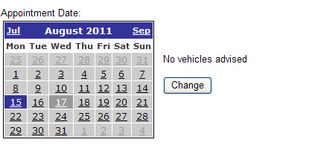

- Input your availability within the 3 working day fields displayed, then select save. Ensure you use a similar format below; otherwise OOCL may not be able to interpret what has been inputted.

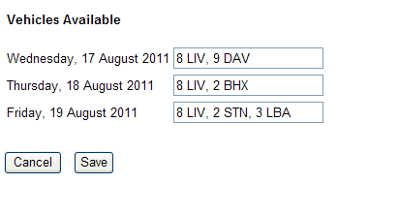
- Once saved, it will display your availability against the relevant day. There is also a date and time advising when this was last updated. This information is sent through the truckcom system.

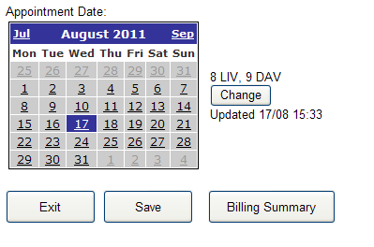
If you use this feature then it is advising OOCL of the vehicles you have available within the specified regions and work will be sent through. Therefore, it is essential that this updated frequently.
Request View Screen.

This screen enables you to view the jobs that are available on any given day. To access this screen you simply click “Go to Request View” on the right of the screen, after logging in. Once logged in, select the date you are looking for work. You’ll also notice that this screen is pale blue; this is to differentiate between the “Request View” and “Subcontracted Jobs” screens.

Select Date

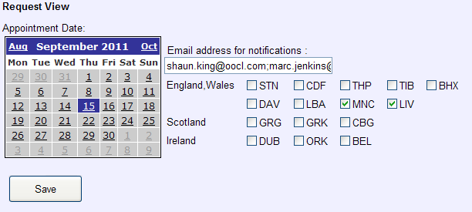

You can enter your email address within the “Email address for notifications” field. This will enable email notifications to be sent to the specified email address advising that jobs have been uploaded to the Request View screen. To filter the emails received please ensure you check the boxes on the areas you wish to notified for, if no boxes are checked then you will not receive any emails. You can also input more than one email address by inserting a semicolon “;” in-between each email address. Once finished click save.

Available jobs are displayed like below. You can request jobs by ticking “Request this job” box. There is also a comments field for additional comments such as requesting to change the empty restitution or empty pickup. Once you have finishing selecting the jobs you require, click save. If you decide you no longer require a requested job then un-tick the “Request this job” box, followed by clicking save.

Import/Export | Box Size & Weight | VIP Customer

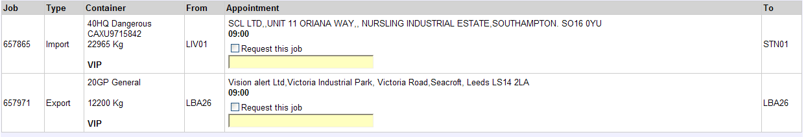

Pickup Location | Request Job | Comments | Finish Location

Please allow up to 1hr, if the job is no longer in this screen then it has been allocated. If you are successful then the job will in appear in your “Subcontracted jobs” screen. Please note if “Dangerous” is displayed next to the box size then it means the job is Hazardous.

There is also a filter function, as below, which will filter the ‘from’ location within the list of available jobs.

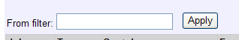

Use the codes below within the filter function then click apply.

